Git Hub Link:
https://github.com/akterfaruq/zero-downtime
Docker Hub Image Link:
https://hub.docker.com/repositories/akterfaruq?_gl=1*178ckvj*_gcl_au*MTExNDUzOTA4My4xNzY0ODI3OTI5*_ga*MjgxNDUzMzk1LjE3NTc0MzgwNTA.*_ga_XJWPQMJYHQ*czE3NjQ5OTI5OTEkbzExJGcxJHQxNzY0OTkyOTk4JGo1MyRsMCRoMA..

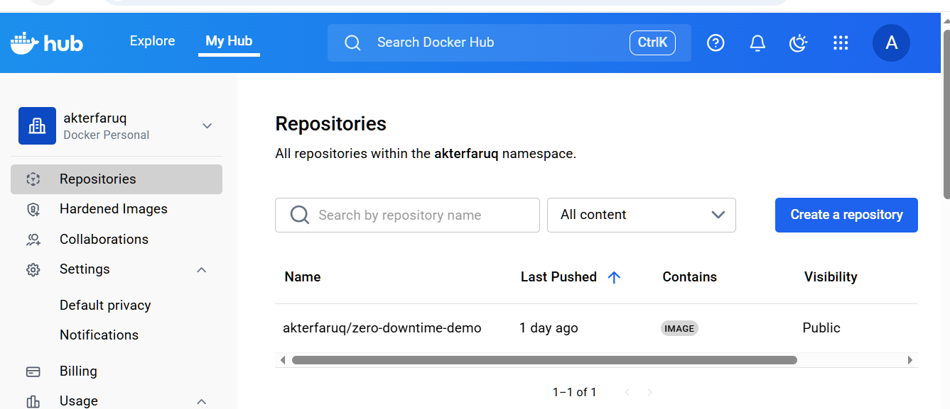

Blue Green Deployemnt:

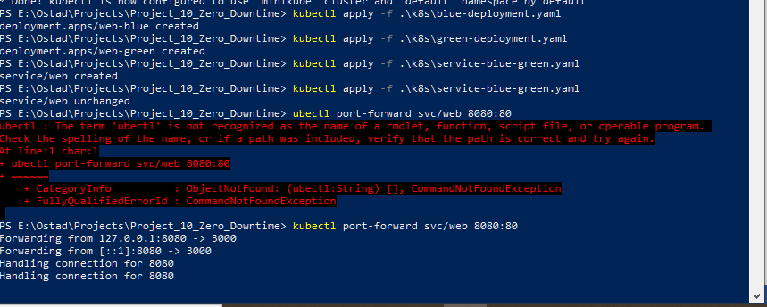
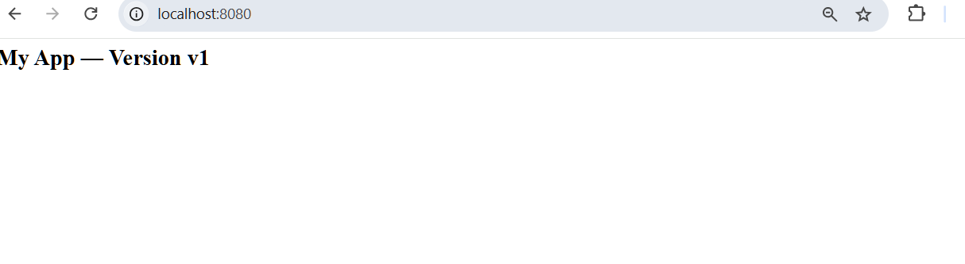

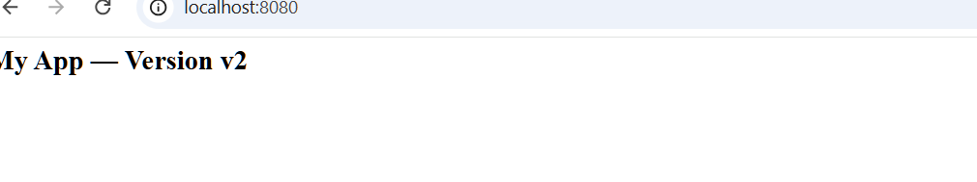

Rolling Update Deployment:

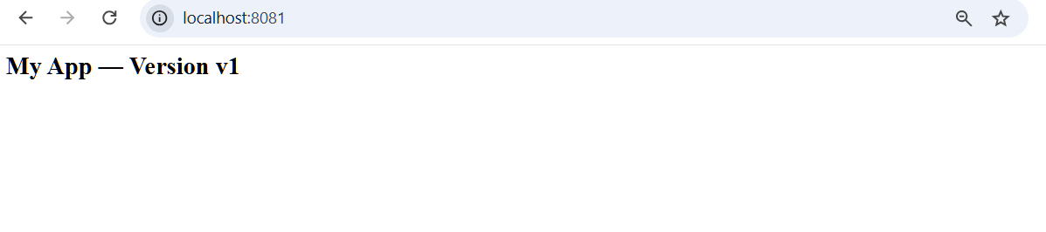

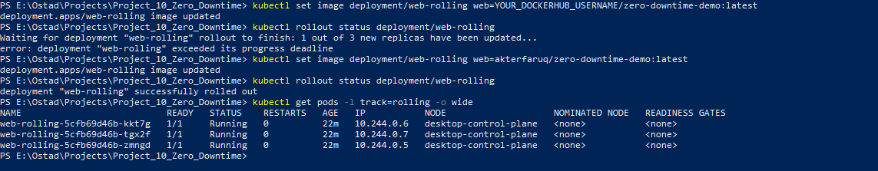

Canary Deployment:

